Project Design Phase-II
Data Flow Diagram & User Stories
Field | Value
Date | 09 March 2026
Team ID | HRMS-MERN-2026
Project Name | HouseRent Management System
Maximum Marks | 4 Marks

Data Flow Diagrams:
A Data Flow Diagram (DFD) is a traditional visual representation of the information flows within a system. A neat and clear DFD can depict the right amount of the system requirement graphically. It shows how data enters and leaves the system, what changes the information, and where data is stored.
DFD Level 1 (Process Breakdown)
The Level 1 DFD breaks down the main system into its core functional processes, showing how data moves through internal modules.
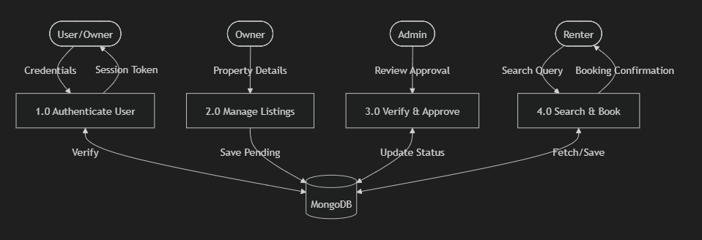

User Stories
Use the below template to list all the user stories for the product.
User Type | Functional Requirement (Epic) | User Story Number | User Story / Task | Acceptance criteria | Priority | Release
Customer | Registration | USN-1 | As a user, I can register for the application by entering my email, password, and profile details. | User can access their account dashboard after registration. | High | Sprint-1
Customer | Login | USN-2 | As a user, I can log in securely to access my saved properties and bookings. | Secure token (JWT) is generated and session is established. | High | Sprint-1
Owner | Property Post | USN-3 | As a property owner, I can post a new property listing with images and price details. | Property appears in "Pending Approval" state for Admin. | High | Sprint-2
Customer | Search | USN-4 | As a user, I can search for properties based on city and budget constraints. | Search results are filtered accurately in real-time. | Medium | Sprint-2
Admin | Verification | USN-5 | As an admin, I can review and approve or reject pending property listings. | Property status changes to "Approved" and becomes visible to all. | High | Sprint-3
Customer | Booking | USN-6 | As a renter, I can book a property for specific check-in/out dates. | Total amount is calculated and booking is saved to history. | High | Sprint-3
Executive / Admin | Monitoring | USN-7 | As an administrator, I can view overall system statistics and manage all users. | Can see total bookings, users, and properties in one view. | Low | Sprint-4
User | Dashboard | USN-8 | As a user, I can manage my personal profile and see my activity history. | Profile updates are saved and history is displayed correctly. | Medium | Sprint-4

